Test Case: tc003_SPX_Dev5_Validar_Funcionalidad_Botones_Add_Remove_Administrador_Roles_Menu
Step 1 - Enter username and password and click to button Enter : Credentials Entered
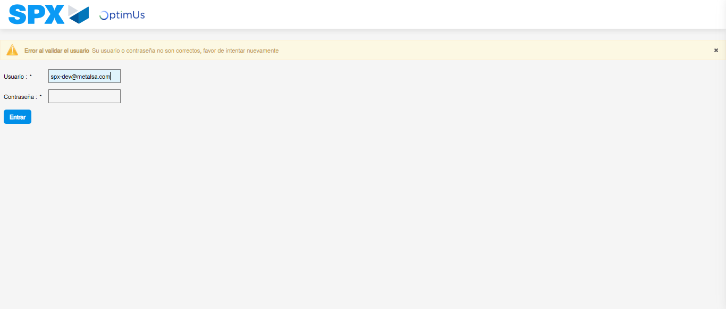Image file-name: QC_Testing-runTestMultipleTimes-nov. 20 2025, 02 21 09 p. m.

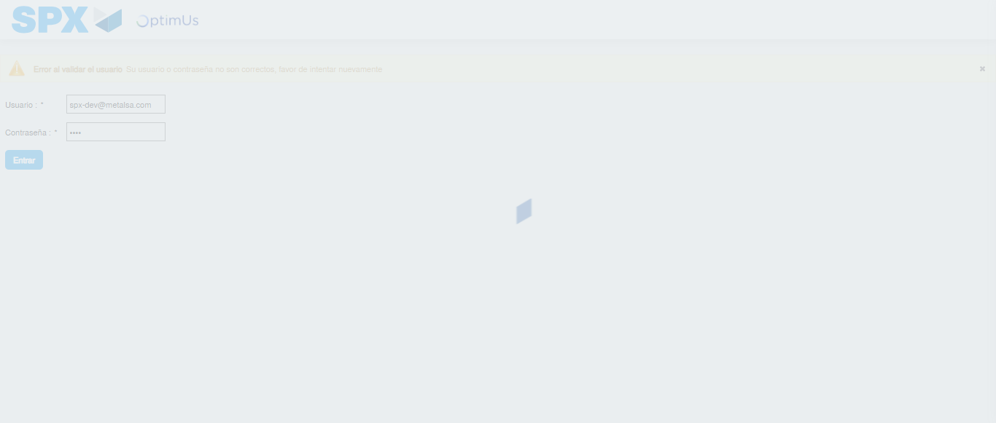Image file-name: QC_Testing-runTestMultipleTimes-nov. 20 2025, 02 21 10 p. m.

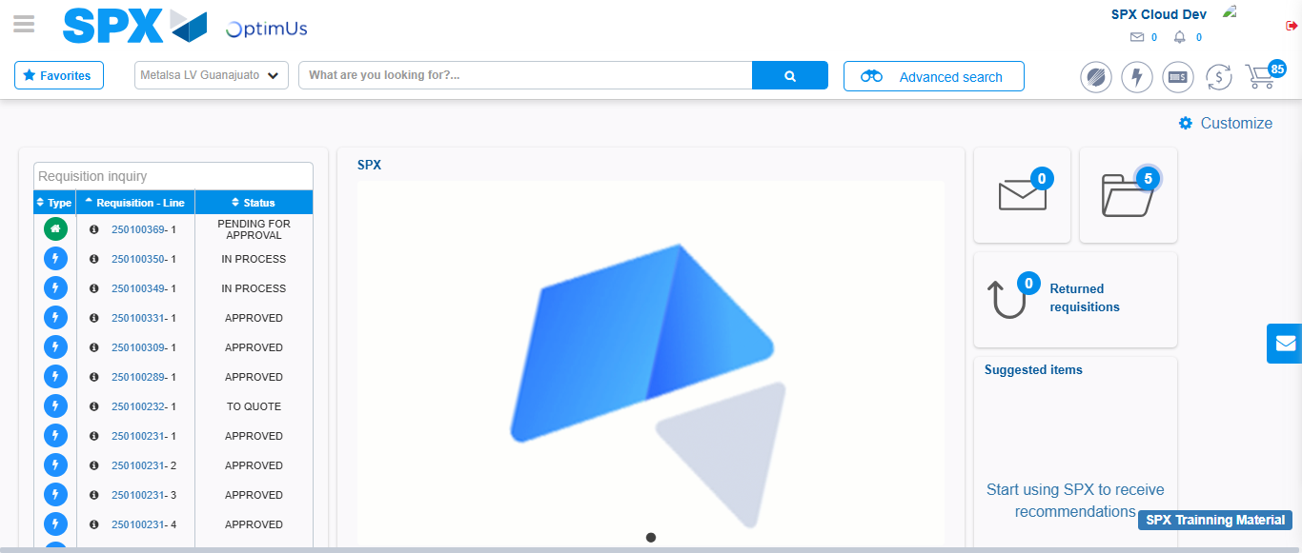Image file-name: QC_Testing-tc001_SPX_Dev5_Validar_Filtro_Campo_MenuName_Administrador_Roles_Menu-nov. 20 2025, 02 21 39 p. m.

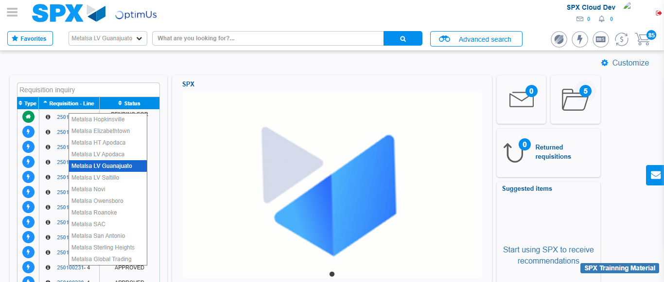Image file-name: QC_Testing-tc002_SPX_Dev5_Validar_Filtro_Campo_URLPath_Administrador_Roles_Menu-nov. 20 2025, 02 22 01 p. m.

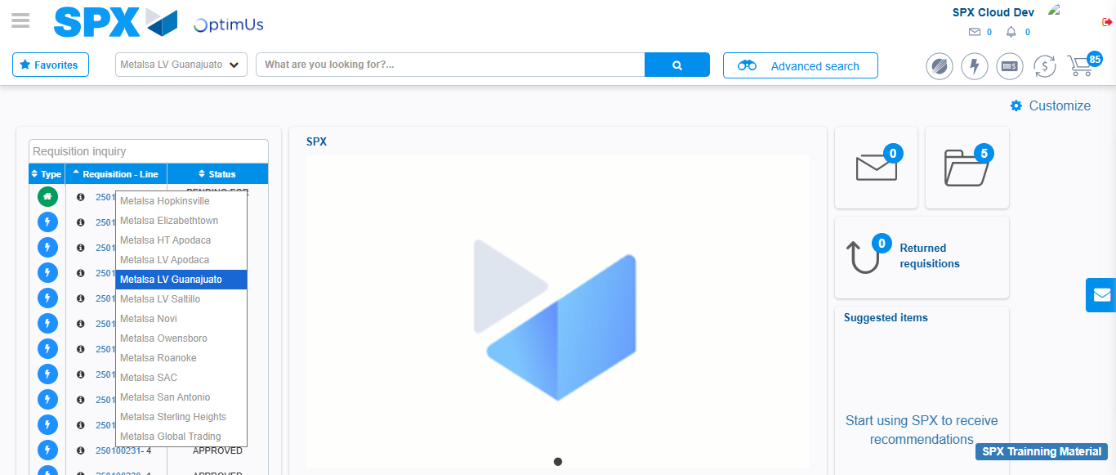Image file-name: QC_Testing-tc003_SPX_Dev5_Validar_Funcionalidad_Botones_Add_Remove_Administrador_Roles_Menu-nov. 20 2025, 02 22 23 p. m.

Step 2 - Select to UEN and Access to Administrador Roles Menu: UEN Correctly selected and Correct access
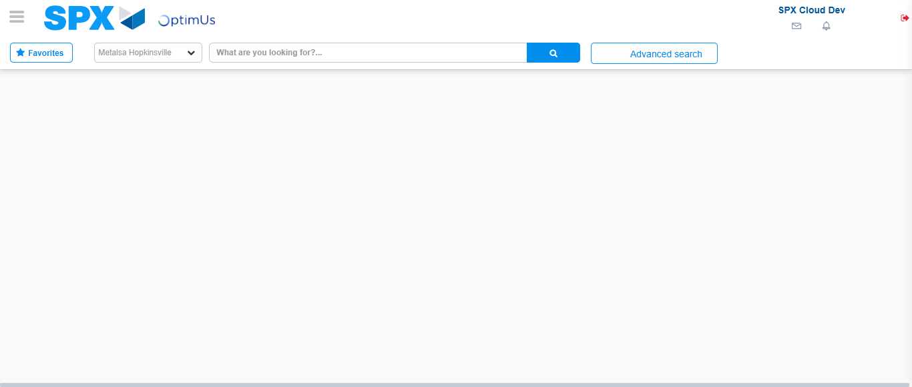Image file-name: QC_Testing-runTestMultipleTimes-nov. 20 2025, 02 21 13 p. m.

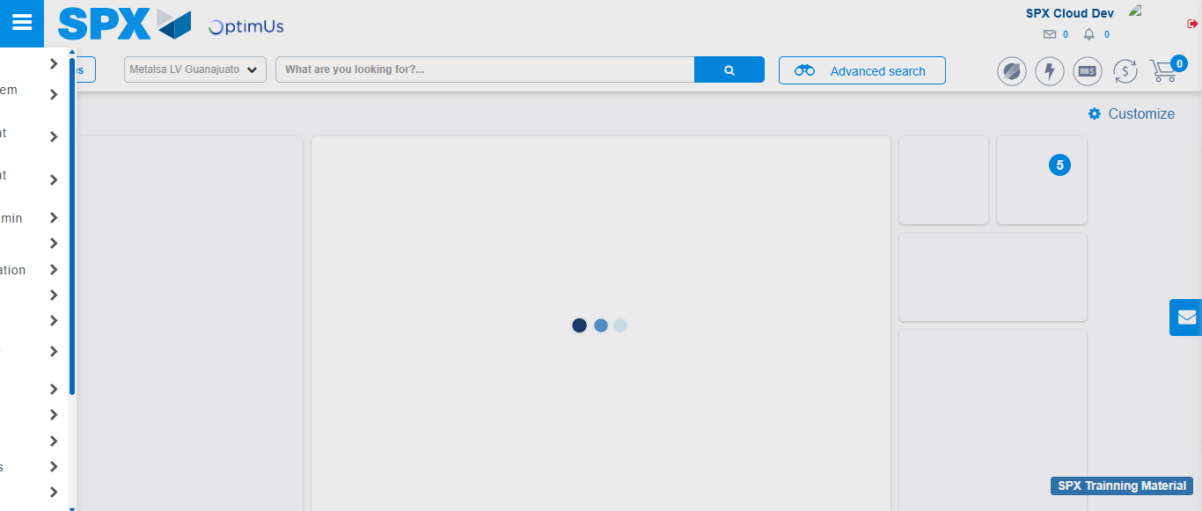Image file-name: QC_Testing-runTestMultipleTimes-nov. 20 2025, 02 21 14 p. m.

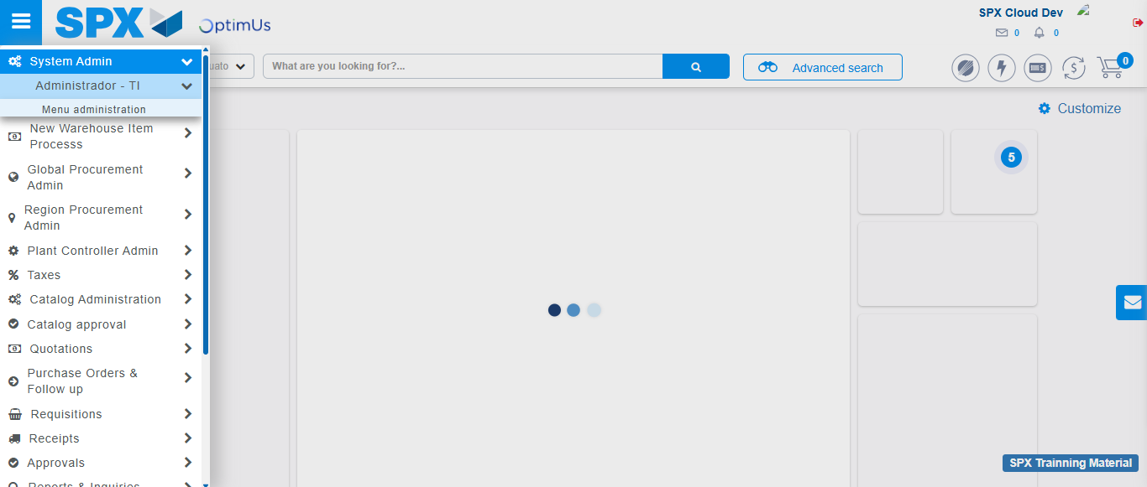Image file-name: QC_Testing-runTestMultipleTimes-nov. 20 2025, 02 21 15 p. m.

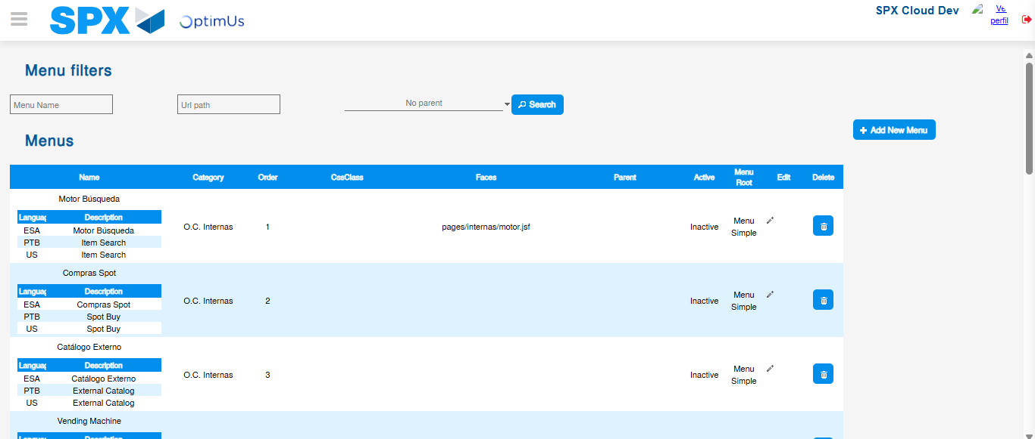Image file-name: QC_Testing-runTestMultipleTimes-nov. 20 2025, 02 21 20 p. m.

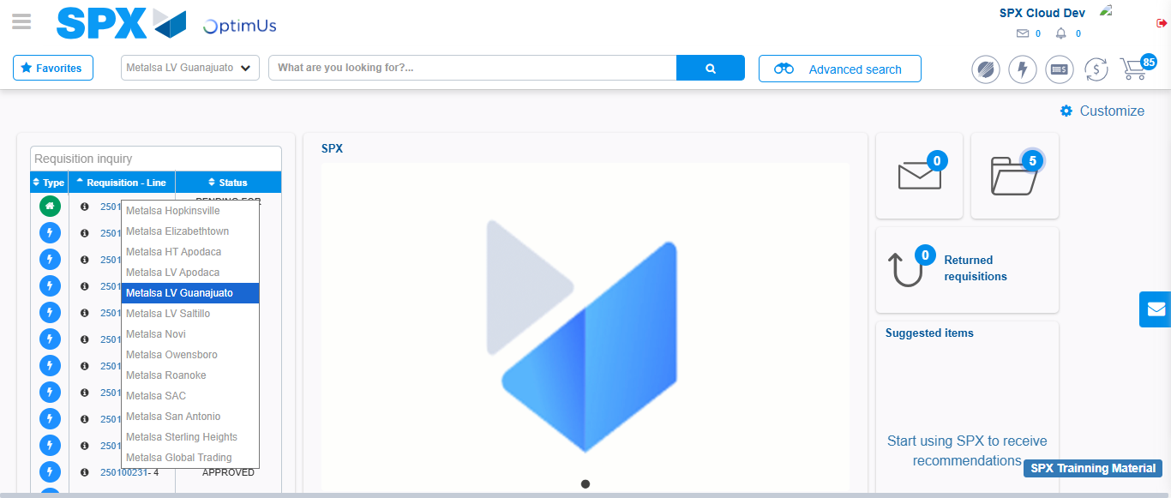Image file-name: QC_Testing-tc001_SPX_Dev5_Validar_Filtro_Campo_MenuName_Administrador_Roles_Menu-nov. 20 2025, 02 21 40 p. m.

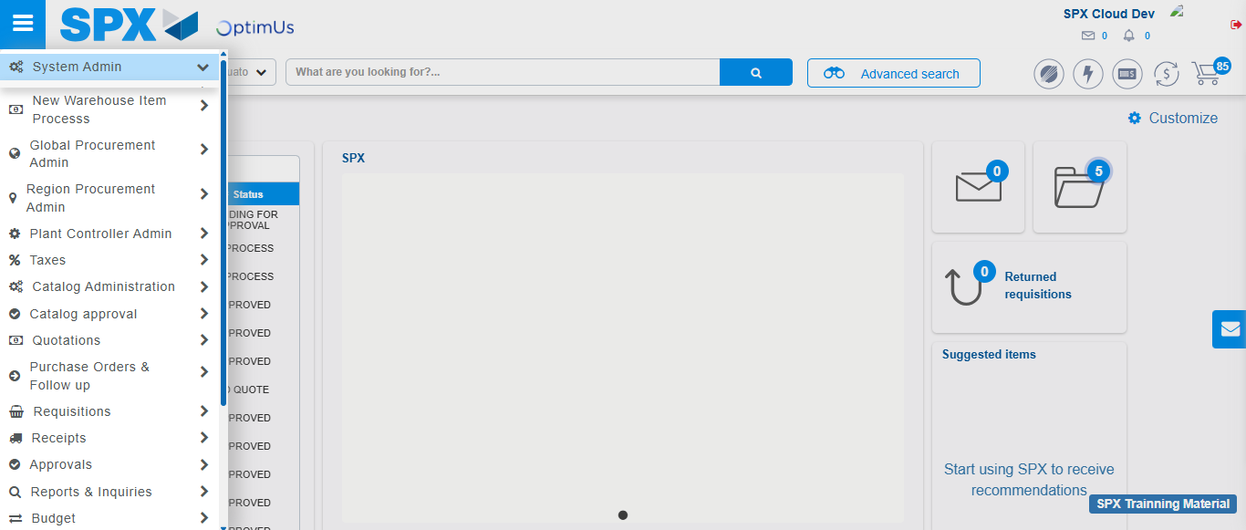Image file-name: QC_Testing-tc001_SPX_Dev5_Validar_Filtro_Campo_MenuName_Administrador_Roles_Menu-nov. 20 2025, 02 21 41 p. m.

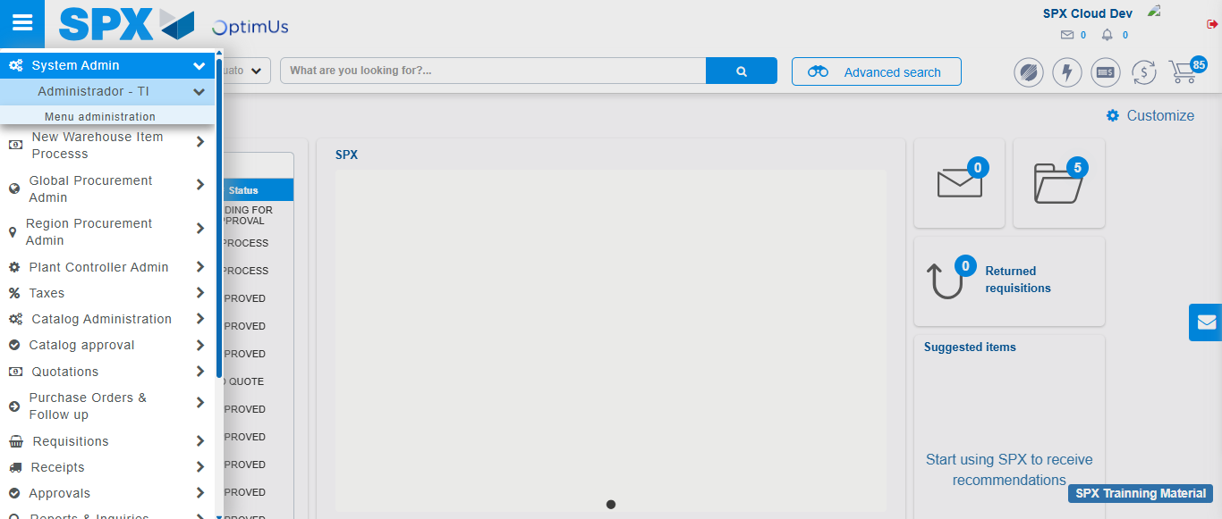Image file-name: QC_Testing-tc001_SPX_Dev5_Validar_Filtro_Campo_MenuName_Administrador_Roles_Menu-nov. 20 2025, 02 21 42 p. m.

Image file-name: QC_Testing-tc001_SPX_Dev5_Validar_Filtro_Campo_MenuName_Administrador_Roles_Menu-nov. 20 2025, 02 21 43 p. m.

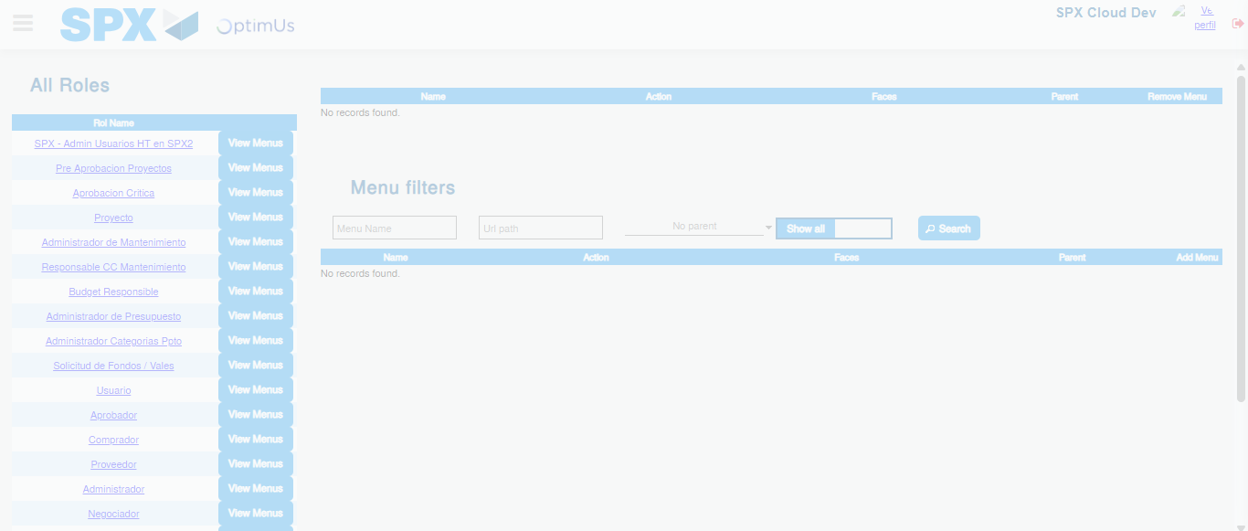Image file-name: QC_Testing-tc001_SPX_Dev5_Validar_Filtro_Campo_MenuName_Administrador_Roles_Menu-nov. 20 2025, 02 21 44 p. m.

Image file-name: QC_Testing-tc002_SPX_Dev5_Validar_Filtro_Campo_URLPath_Administrador_Roles_Menu-nov. 20 2025, 02 22 01 p. m.

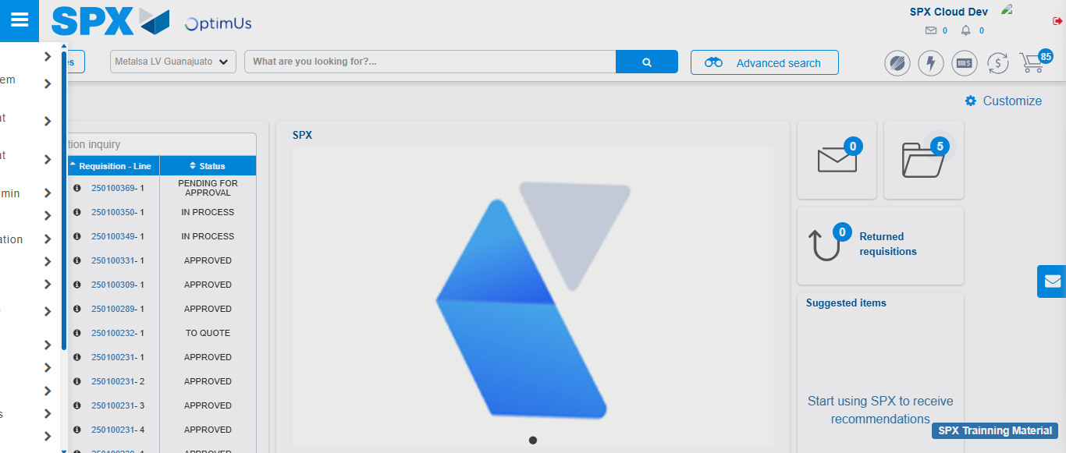Image file-name: QC_Testing-tc002_SPX_Dev5_Validar_Filtro_Campo_URLPath_Administrador_Roles_Menu-nov. 20 2025, 02 22 02 p. m.

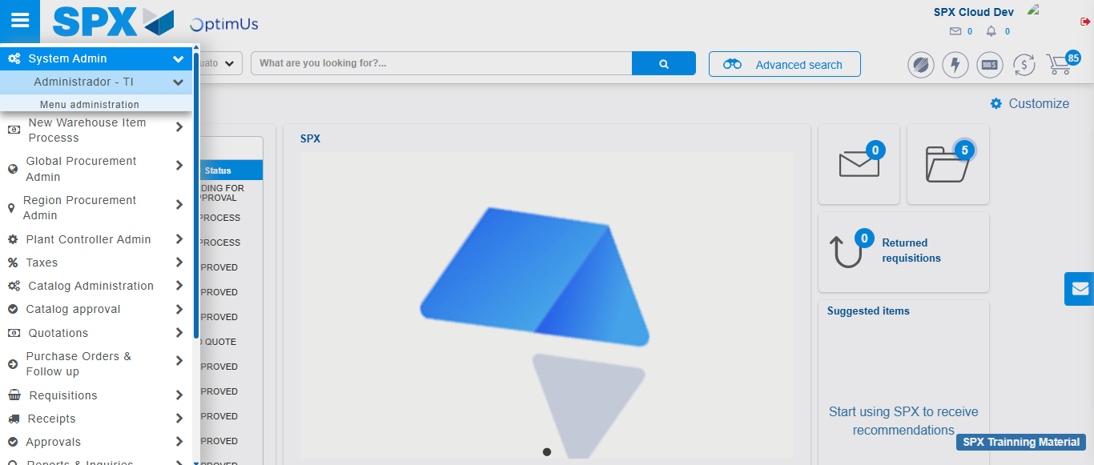Image file-name: QC_Testing-tc002_SPX_Dev5_Validar_Filtro_Campo_URLPath_Administrador_Roles_Menu-nov. 20 2025, 02 22 03 p. m.

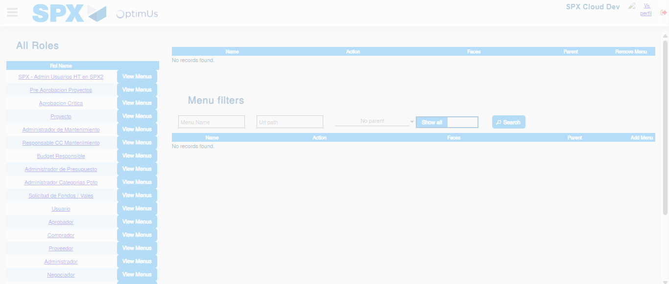Image file-name: QC_Testing-tc002_SPX_Dev5_Validar_Filtro_Campo_URLPath_Administrador_Roles_Menu-nov. 20 2025, 02 22 05 p. m.

Image file-name: QC_Testing-tc003_SPX_Dev5_Validar_Funcionalidad_Botones_Add_Remove_Administrador_Roles_Menu-nov. 20 2025, 02 22 23 p. m.

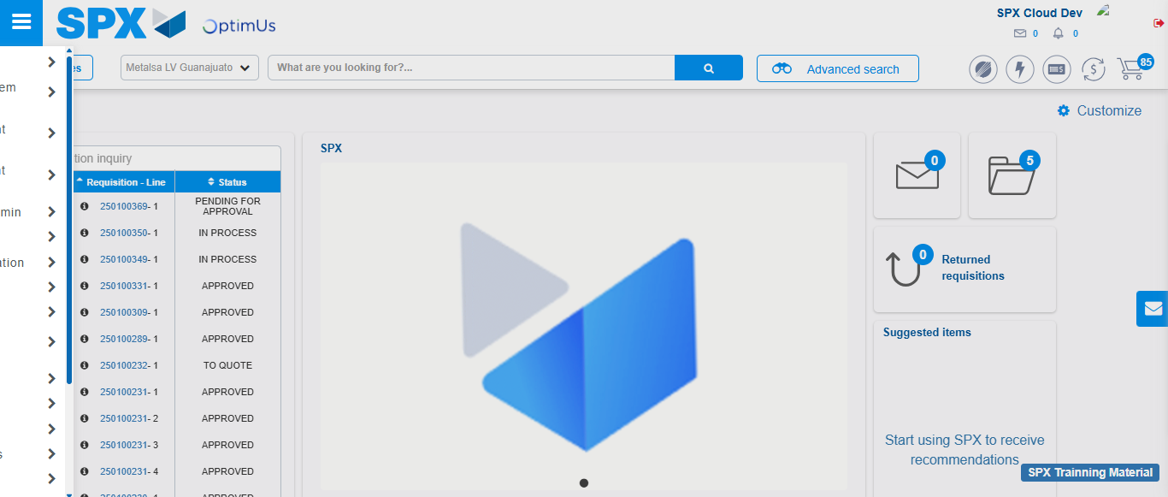Image file-name: QC_Testing-tc003_SPX_Dev5_Validar_Funcionalidad_Botones_Add_Remove_Administrador_Roles_Menu-nov. 20 2025, 02 22 24 p. m.

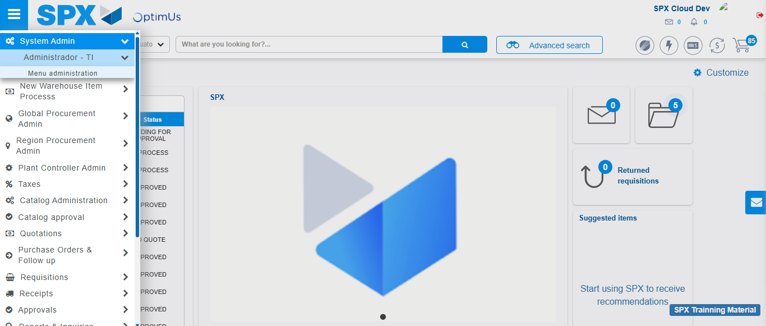Image file-name: QC_Testing-tc003_SPX_Dev5_Validar_Funcionalidad_Botones_Add_Remove_Administrador_Roles_Menu-nov. 20 2025, 02 22 25 p. m.

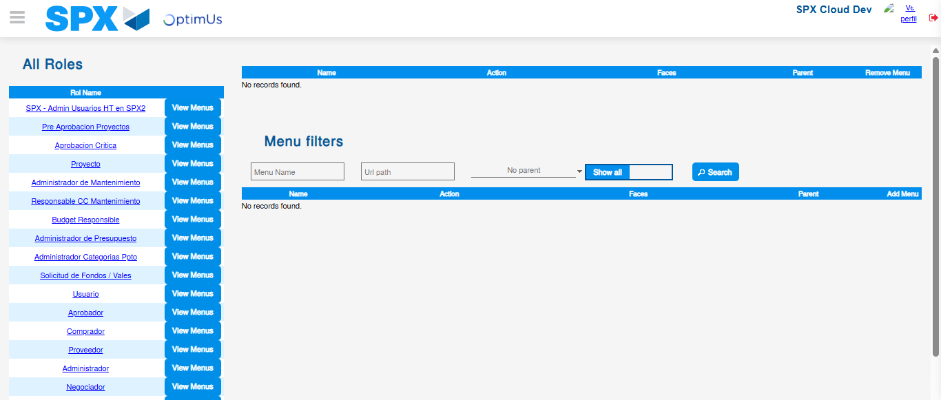Image file-name: QC_Testing-tc003_SPX_Dev5_Validar_Funcionalidad_Botones_Add_Remove_Administrador_Roles_Menu-nov. 20 2025, 02 22 26 p. m.

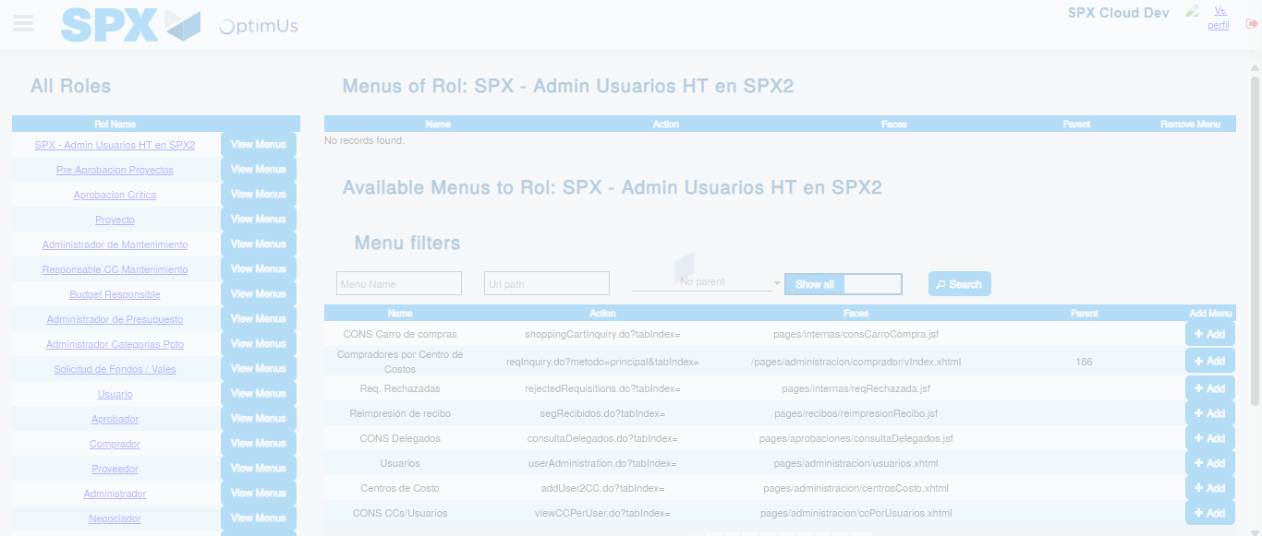Image file-name: QC_Testing-tc003_SPX_Dev5_Validar_Funcionalidad_Botones_Add_Remove_Administrador_Roles_Menu-nov. 20 2025, 02 22 27 p. m.

Step 3 - Click to Buttons View Menu and Search Filter with Menu Name and Add new record and Delete Record: Correct Search and Record successfully added and Record successfully deleted
Image file-name: QC_Testing-tc001_SPX_Dev5_Validar_Filtro_Campo_MenuName_Administrador_Roles_Menu-nov. 20 2025, 02 21 44 p. m.

Image file-name: QC_Testing-tc002_SPX_Dev5_Validar_Filtro_Campo_URLPath_Administrador_Roles_Menu-nov. 20 2025, 02 22 05 p. m.

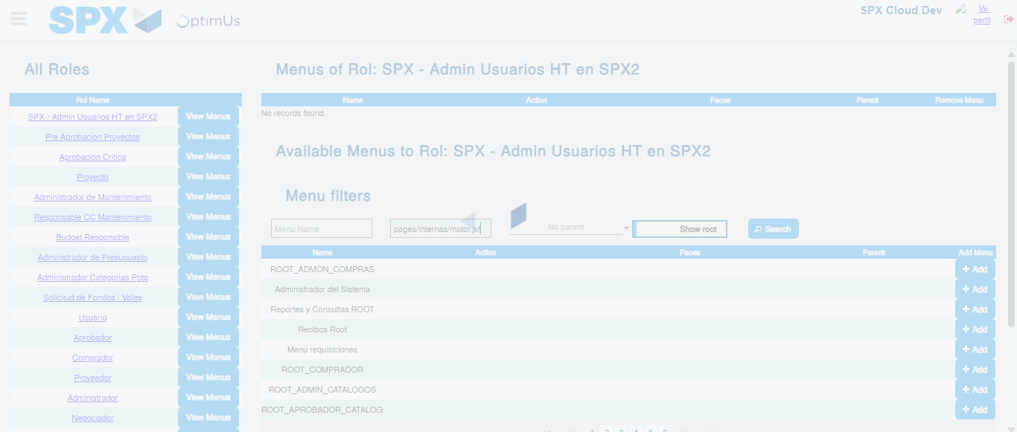Image file-name: QC_Testing-tc002_SPX_Dev5_Validar_Filtro_Campo_URLPath_Administrador_Roles_Menu-nov. 20 2025, 02 22 06 p. m.

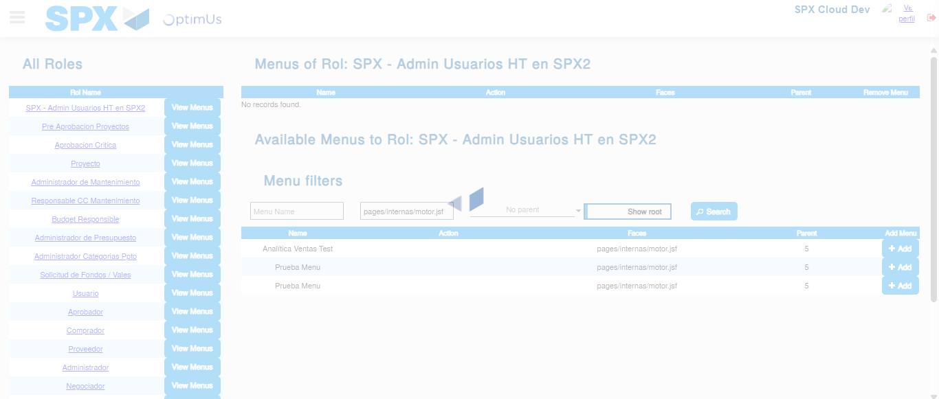Image file-name: QC_Testing-tc002_SPX_Dev5_Validar_Filtro_Campo_URLPath_Administrador_Roles_Menu-nov. 20 2025, 02 22 07 p. m.

Image file-name: QC_Testing-tc003_SPX_Dev5_Validar_Funcionalidad_Botones_Add_Remove_Administrador_Roles_Menu-nov. 20 2025, 02 22 27 p. m.

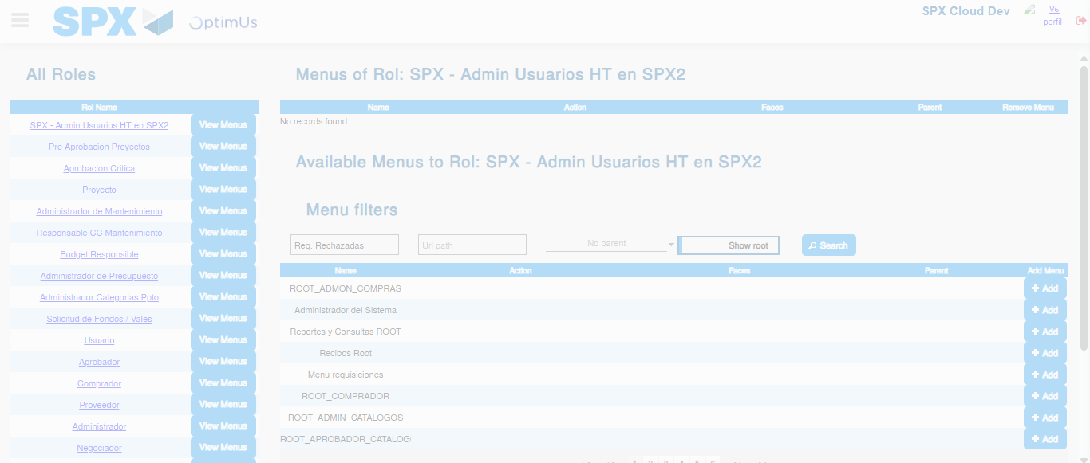Image file-name: QC_Testing-tc003_SPX_Dev5_Validar_Funcionalidad_Botones_Add_Remove_Administrador_Roles_Menu-nov. 20 2025, 02 22 28 p. m.

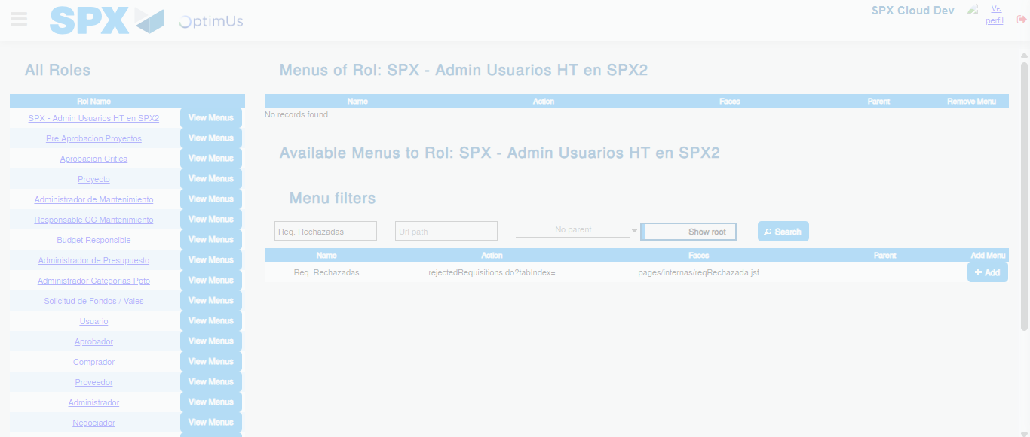Image file-name: QC_Testing-tc003_SPX_Dev5_Validar_Funcionalidad_Botones_Add_Remove_Administrador_Roles_Menu-nov. 20 2025, 02 22 29 p. m.

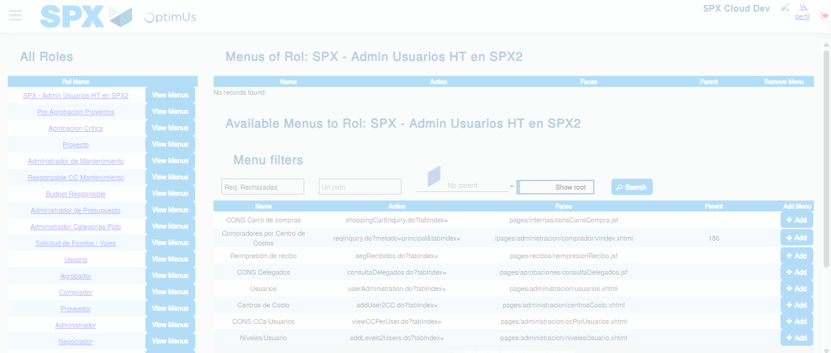Image file-name: QC_Testing-tc003_SPX_Dev5_Validar_Funcionalidad_Botones_Add_Remove_Administrador_Roles_Menu-nov. 20 2025, 02 22 33 p. m.

